Design of Machine Elements Proposal



*Group Members:*

**MUHAMMAD FAIQ NASIR**  **(201075)**

**MUAMMAD WALEED TARIQ** **(201111)**

**SAUD MUBASHIR** **(201147)**

Submitted to: Dr. Imran Shah

Mobile Robotic Base Stress and Safety Factor Analysis

# Introduction

In the realm of robotics, the functionality of a robotic base is paramount, serving as the bedrock upon which the capabilities of a robot are built. This foundational platform facilitates the robot's mobility, stability, and adaptability across a spectrum of environments. The intricate interplay of mobility systems, sensors, control mechanisms, and integration with various payloads defines the essence of a robotic base. As we delve into the stress and safety factor analysis of a mobile robotic base, we embark on a journey to unravel the engineering intricacies that underpin its design and operation. This exploration will shed light on how robust structural considerations contribute to the reliability and efficiency of robotic systems, paving the way for innovation and advancement in the field of robotics.

# Model

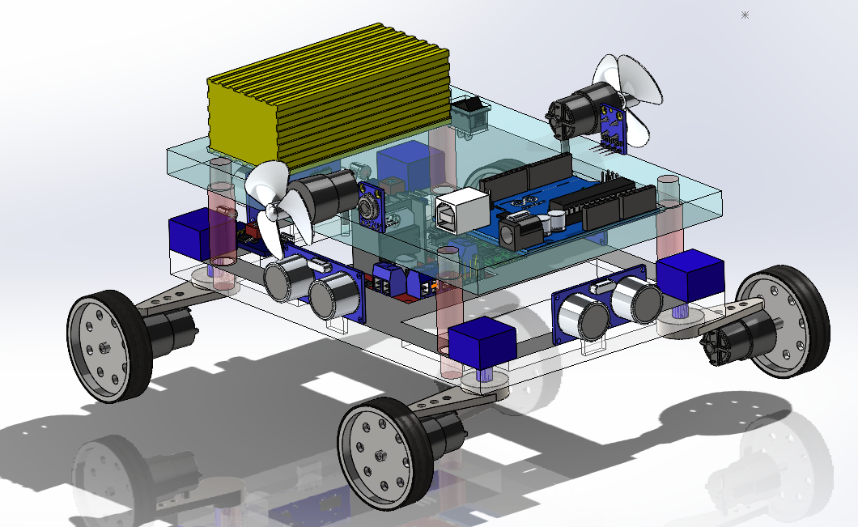

# Objective

## Comprehensive Understanding of Mobile Robotic Base Components:

Gain an in-depth knowledge of the various components constituting a mobile robotic base, emphasizing their individual weights and collective contributions to the overall load.

## Theoretical Foundation in Stress Analysis and Safety Factors:

Develop a robust theoretical understanding of stress analysis, with a focus on the implications of component loading on the structural integrity of the mobile robotic base.

## SolidWorks Proficiency:

Attain proficiency in utilizing SolidWorks for creating a 3D model of the mobile robotic base, incorporating the weights and distribution of individual components.

## Load Analysis with Component Weights:

Analyze the external loads and forces acting on the mobile robotic base, considering the weights of individual components.

Incorporate dynamic and static loads, environmental factors, and the impact of component interactions.

## Stress Analysis Considering Component Loading:

Perform stress analysis on the SolidWorks model, factoring in the loads imposed by the weights of each component.

Evaluate stress distribution in critical areas of the robotic base under different operational scenarios.

## Safety Factor Calculation for the Entire Robotic System:

Calculate safety factors for the entire robotic system, considering the cumulative loading effects of all components.

Assess the safety margins for critical components and the overall system reliability.

## Comparison with Manual Calculations:

Perform manual calculations for stress and safety factor analysis, integrating the weights of individual components.

Compare SolidWorks simulation results with manual calculations to validate the accuracy of the modeling approach.

## Documentation and Reporting:

Prepare detailed documentation outlining the design process, analysis methodology, and results, with specific emphasis on the impact of individual component loading.

Present a final report highlighting the implications for design improvements and the overall system's reliability.